**Project name: Healthfirst Care initiative**

**BPMN & Swimlane Diagrams**

**Introduction**

Process modeling plays a critical role in analyzing and improving operational workflows in organizations. By visually mapping processes, it becomes easier to identify inefficiencies, clarify stakeholder responsibilities, and streamline activities. This report presents the analysis of current workflows (“As-Is”), highlights operational challenges, and proposes optimized (“To-Be”) processes for HealthFirst Care to enhance efficiency and patient satisfaction

**As-Is Process Summary**

Currently, the appointment scheduling and patient check-in processes at HealthFirst Care rely heavily on **manual workflows**. Patients request appointments via in-person visits or phone calls. Administrative staff manually check for slot availability and book appointments, often resulting in errors or delays. Patient check-ins at the hospital are also manual, involving paperwork and long waiting times. Communication between departments (e.g., administration and IT teams) is often fragmented, leading to slow responses to resource requests or issues.

**Challenges Identified**

1. **Manual Appointment Booking Delays**
   * Slots often double-booked or unavailable
   * Time-consuming verification by administrative staff
2. **Communication Issues**
   * Manual, informal communication between teams
   * Delayed responses from IT regarding technical support
3. **Manual Patient Check-Ins**
   * Time wasted on filling forms and waiting for verification
   * Limited visibility of patient arrival for relevant departments

**Proposed Improvements (To-Be)**

1. **Automated Appointment Booking**
   * Patients can request appointments online or via mobile applications
   * System automatically checks for conflicts and sends real-time confirmations
2. **Online/Self-Service Patient Check-In**
   * Introduction of online check-in portals or kiosks in the hospital
   * Immediate notifications to relevant staff upon check-in completion
3. **Dashboard/Task Management for Departments**
   * Implementation of centralized dashboards for tracking requests, resources, and progress
   * Automated alerts for pending or delayed tasks across departments

**Expected Benefits**

* **Reduced Delays**: Automation eliminates manual bottlenecks and speeds up key processes
* **Better Communication**: Digital dashboards foster transparency and faster interdepartmental coordination
* **Improved Patient Satisfaction**: Patients benefit from shorter wait times, timely notifications, and smoother hospital visits

**Advanced BPMN Diagrams-**

Appointment Scheduling (As-Is)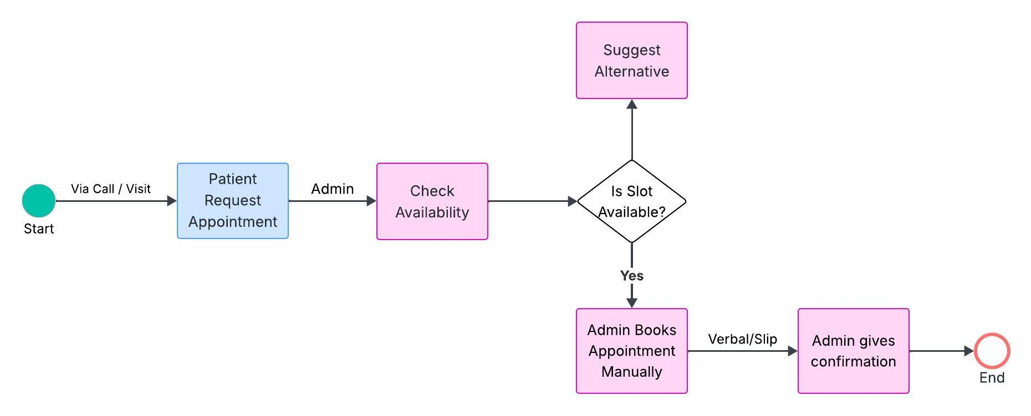

Appointment scheduling (To-Be)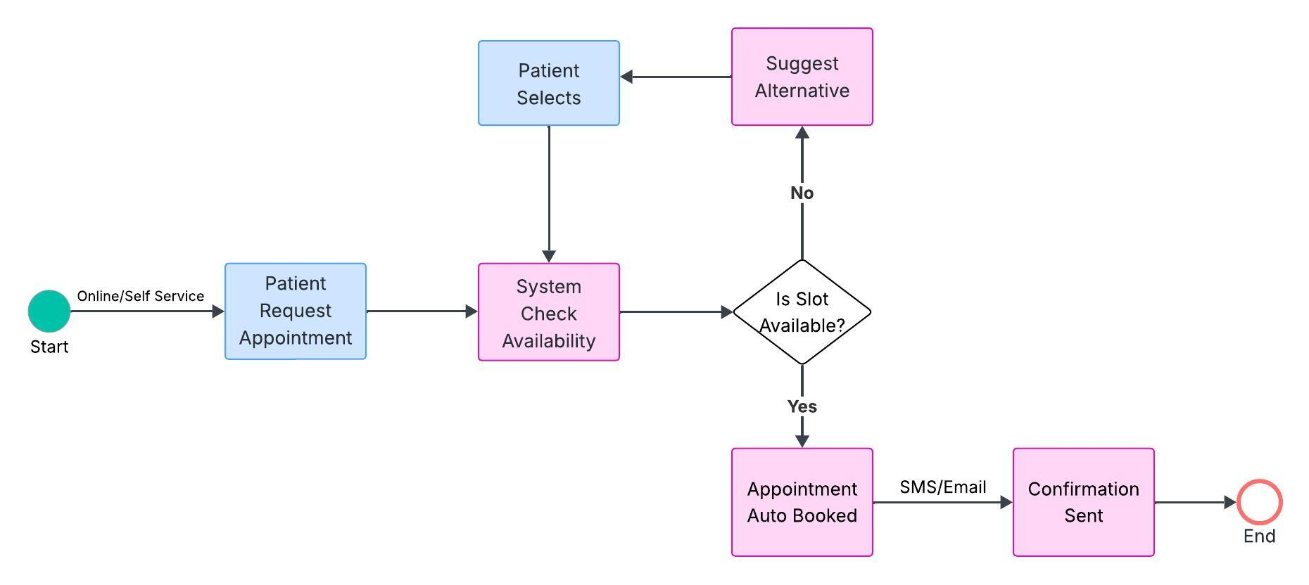

Patient Discharge Process (As-Is)

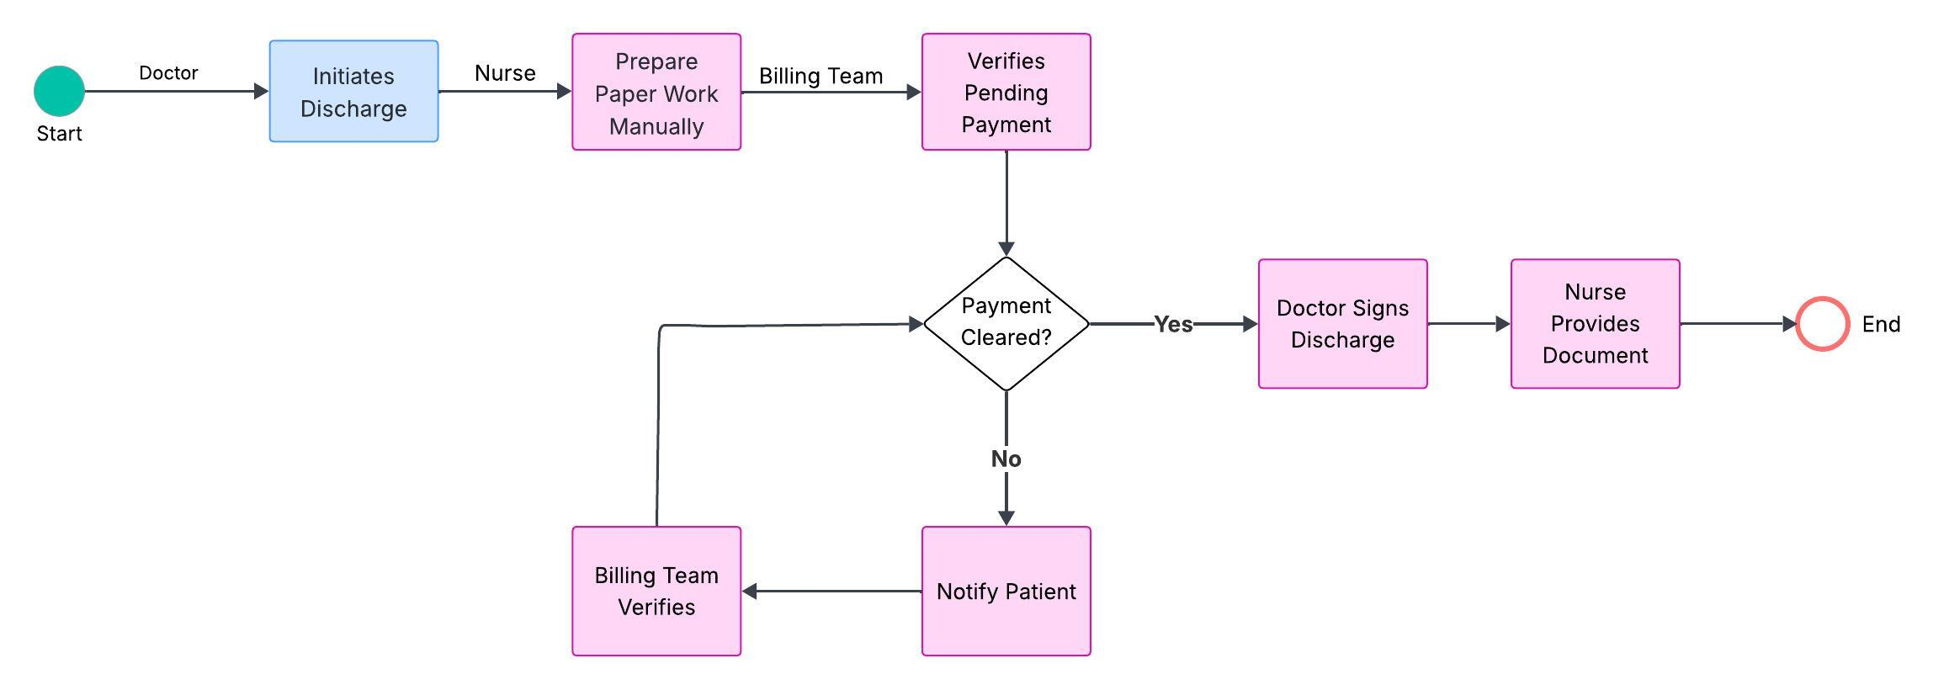

Patient Discharge Process (To-Be)

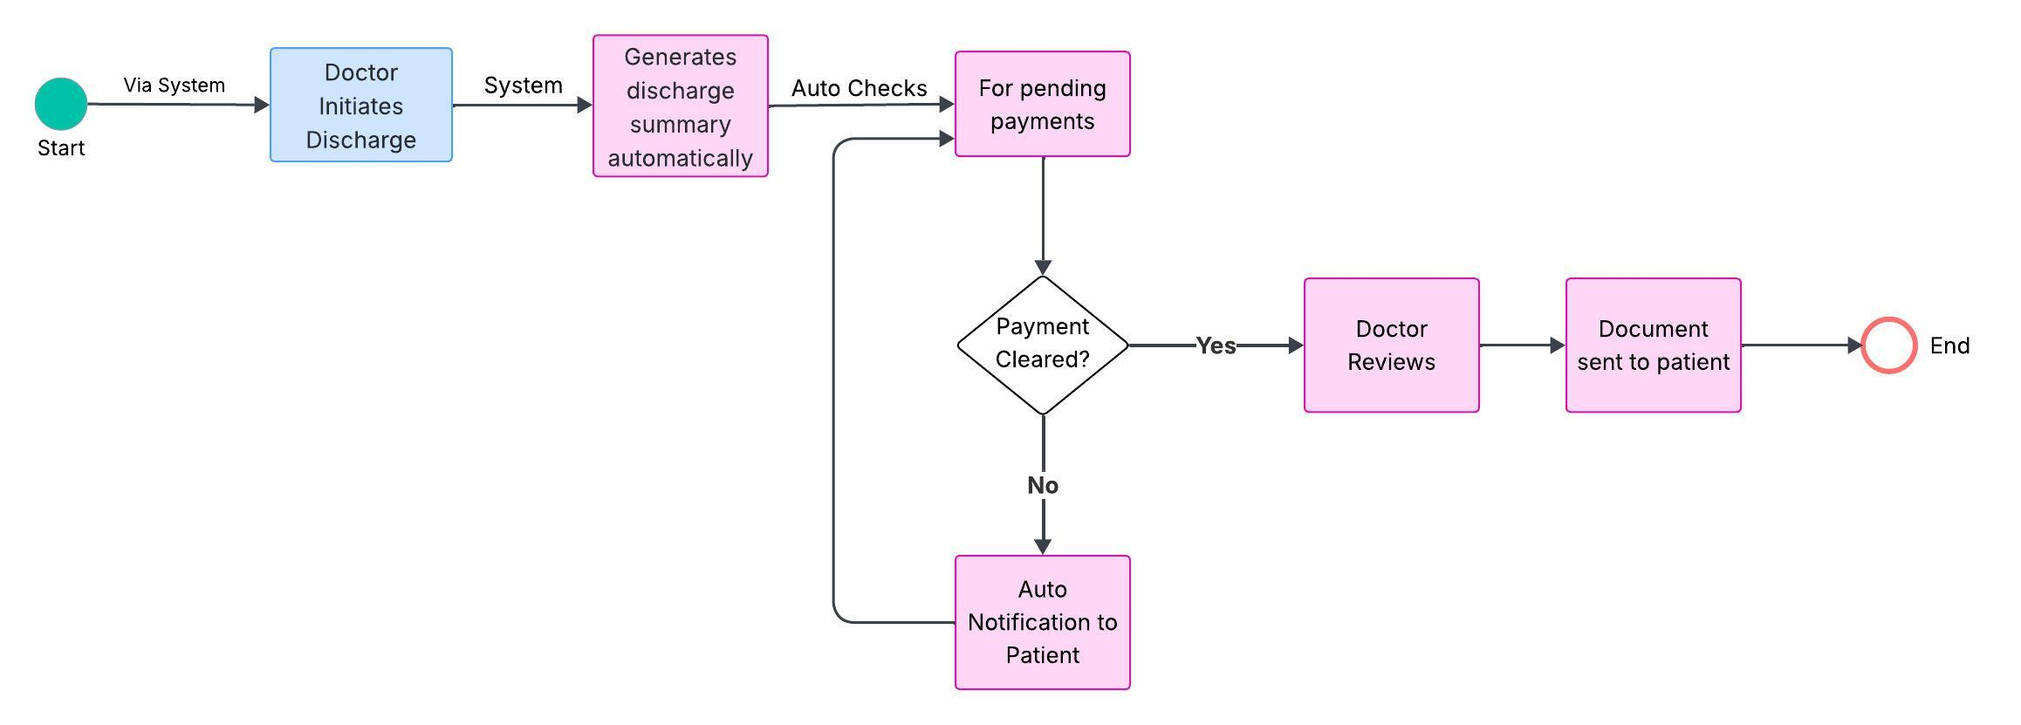

**Swimlane Diagram-**

Appointment Scheduling Process (To-Be)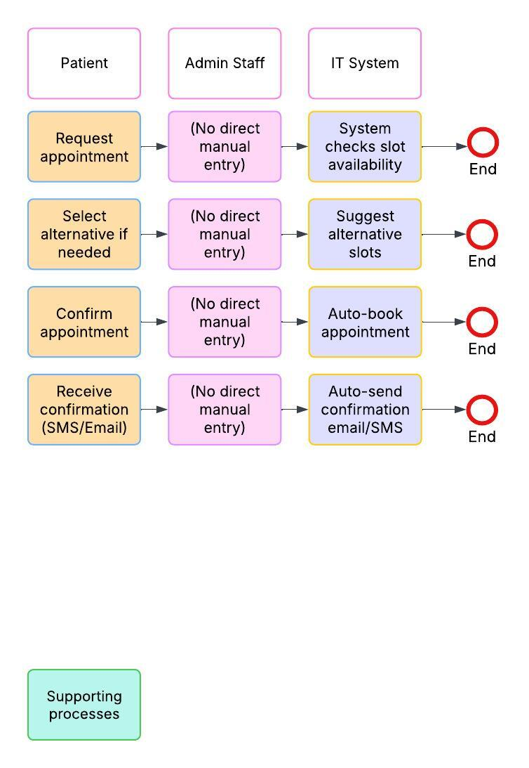

Patient Discharge Process (To-Be)